Ideation Phase Empathize & Discover

Date | 15 Feb 2026
Team ID | LTVIP2026TMIDS44629
Project Name | Measuring the Pulse of Prosperity: An Index of Economic Freedom Analysis
Maximum Marks | 4 Marks

Empathy Map Canvas:
An empathy map is a simple and visual tool that captures knowledge about users’ behaviors, needs, and challenges.
The primary user of the Economic Freedom Analysis Dashboard is a policy maker, economist, researcher, or business strategist who needs to monitor national economic performance, regulatory efficiency, and market openness. These users often work with large volumes of raw statistical data from international economic reports but lack a centralized platform to analyze trends, compare countries, or evaluate reform outcomes effectively.
Due to the absence of interactive and visual analytics tools, users often feel overwhelmed and uncertain when making policy recommendations, investment decisions, or economic assessments. They require a comprehensive, user-friendly dashboard that presents clear KPIs, trend analysis, country comparisons, and indicator-level insights.
A well-designed Tableau dashboard can transform complex economic data into actionable insights, enabling informed decision-making, evidence-based policy reforms, and strategic planning to enhance economic freedom and national prosperity.
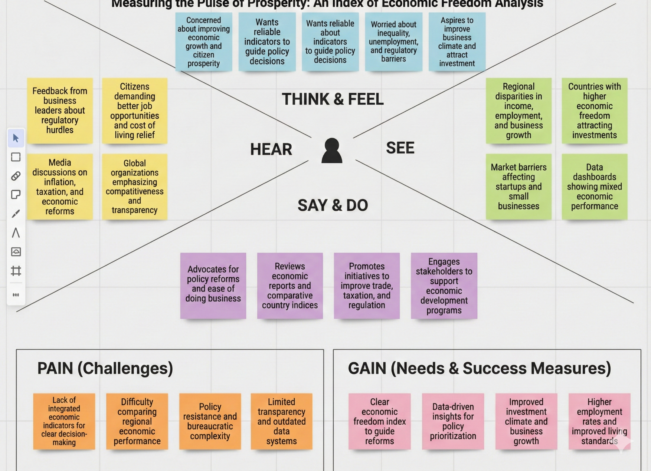
Higher employment rates

